ST MARIS HIGH SCHOOL


WELCOME TO ST. MARIS HIGH SCHOOL ENTEBBE – EXCELLENCE IN EDUCATION & CHARACTER.

St Maris is a catholic founded high school, located in Entebbe. Established in 1998, we are committed to nurturing students hostically through academic excellence, strong discipline, and Christian moral values. We offer both O-Level (S1-S2) and A-Level (S5-S6) with Arts and Sciences.
Discipline | Integrity | Excellence
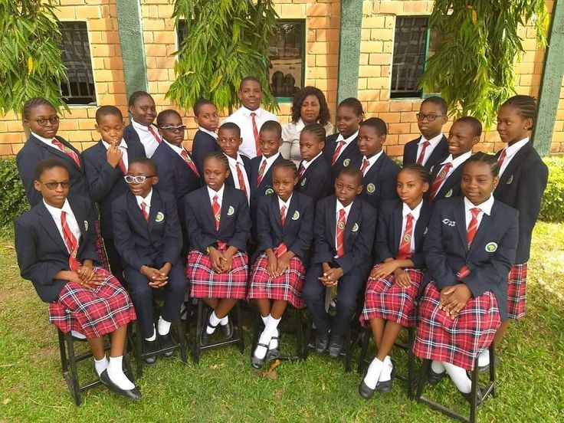
EMAIL: info@stmarishigh.ac.ug
PHONE: +256 708 177 648 /+256 774 091 801
ADDRESS: P.O.BOX 117, ENTEBBE ROAD, ENTEBBE UGANDA

ABOUT US
St Maris High school Entebbe is a catholic founded private school located along Entebbe road, Entebbe Uganda. The school was established in 1998 with the aim of providing quality education rooted in Christian values.
For over years, the school has been committed to nurturing students, hostically – academically, morally, and socially. We offer both O-Level (senior 5 to senior 6) programs under the new Competence – Based curriculum (CBC).
The school has qualified teachers, modern science laboratories, computer lab, library, and sports facilities. Our students excel in both academic and co-curricular activities.
OUR VISION: To be a leading centre of academic excellence that forms responsible, knowledgeable, compassionate and God fearing leaders.
OUR MISSION: To provide quality education rooted in Christian values, empowering students to achieve academic excellence and develop leadership skills

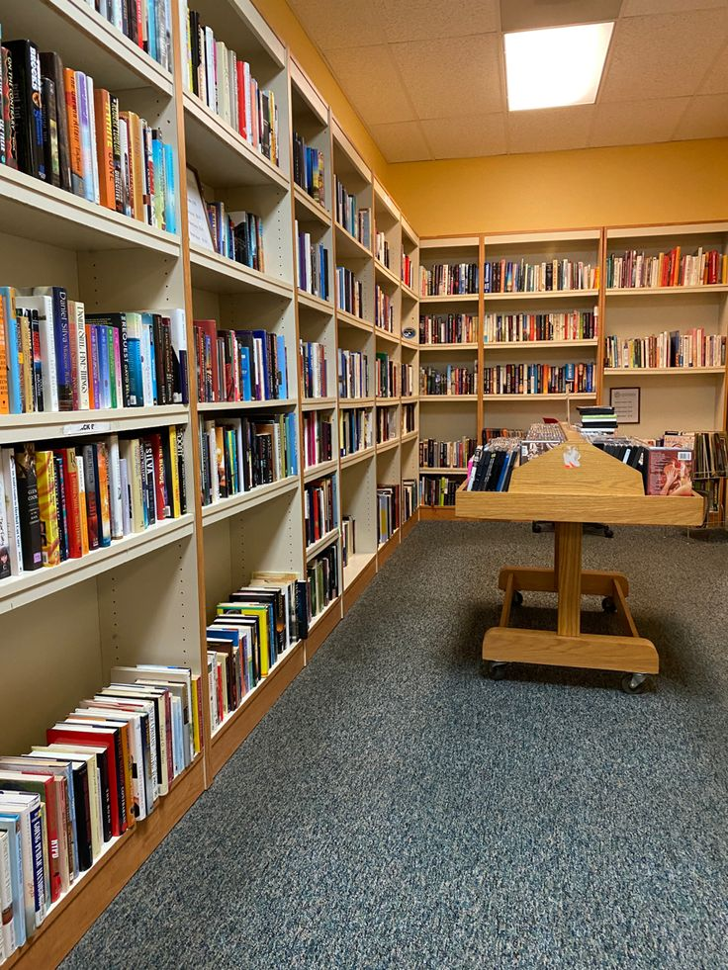

OUR ACADEMIC AND PROGRAM SERVICES
Explowerour comprehensive academic programmes designed to empower students from S1 to S6 with knowledge, skills and leadership for the future.
  SCIENCE PROGRAMS  - Biology, chemistry, physics lab  - Stem and innovation  - S1 to S6 |   BUSINESS & HUMANITIES  - History, geography, entrepreneurship, literature.  - Leadership and debate club. |   VOCATIONAL &LIFESKILL  - Life skill and guidance.  - it and computer studies.  - agriculture and enviromental

GALLERY PAGE
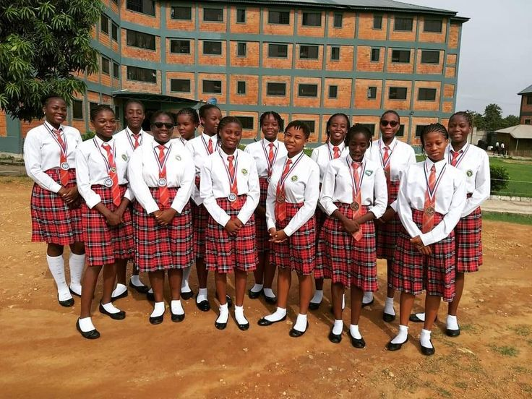
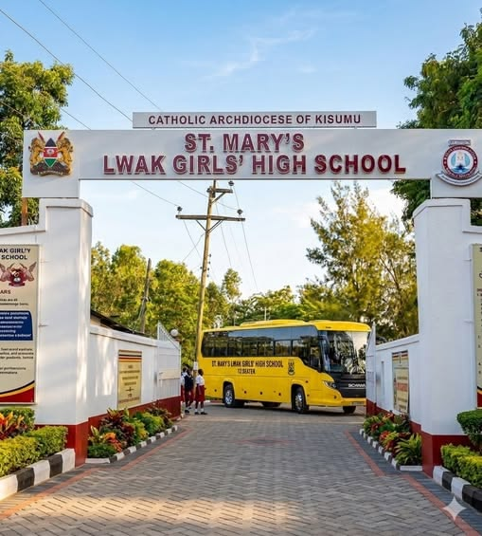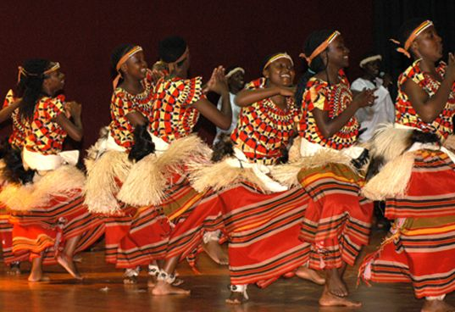

Contact us on +256708177648/ info@stmarishigh.ac.ug
Working hours: Mon- Fri 8am-5pm
Follow us Facebook/ Instagram/ Twitter.

